**NAAN MUDHAVAN**

**ASSIGNMENT DOCUMENT**

**COURSE TITLE** : DIGITAL MARKETING

**COLLEGE CODE** : 1105

**COLLEGE NAME** : GOJAN SCHOOL OF BUSINESS AND TECHNOLOGY

**NM ID** : 47D90DE0C9F24E59CB8496B93F8D07D0

**NAME** : GOKUL M

**REGISTER NUMBER** : 110520106003

**YEAR** : 4TH YEAR

**DEPARTMENT** : ELECTRONICS AND COMMUNICATION ENGINEERING

1. Create a blog or website using Blogspot and Wordpress. Customize the theme design and post new article with 500 words.

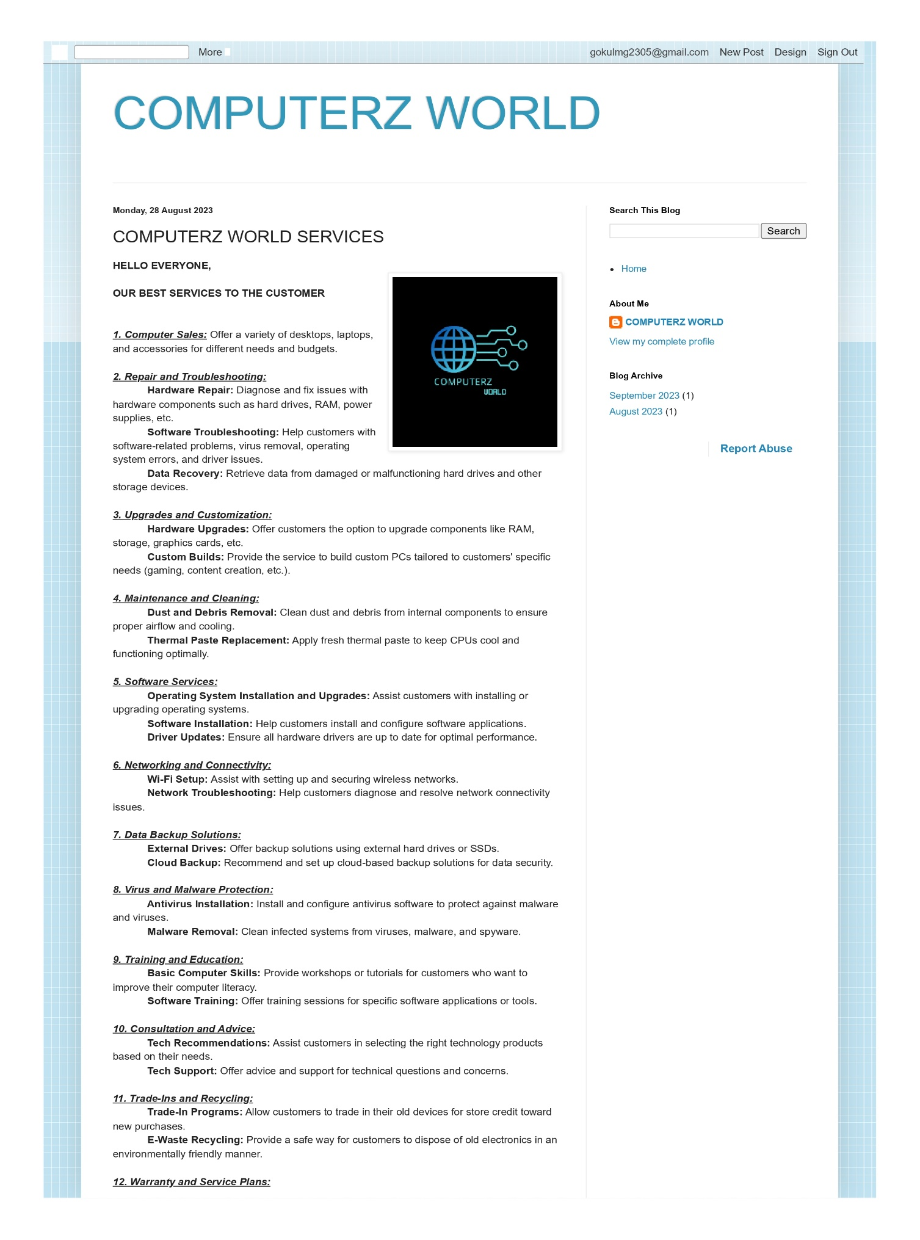Link: <https://computerzzzworld.blogspot.com/2023/08/computerz-world-services.html>

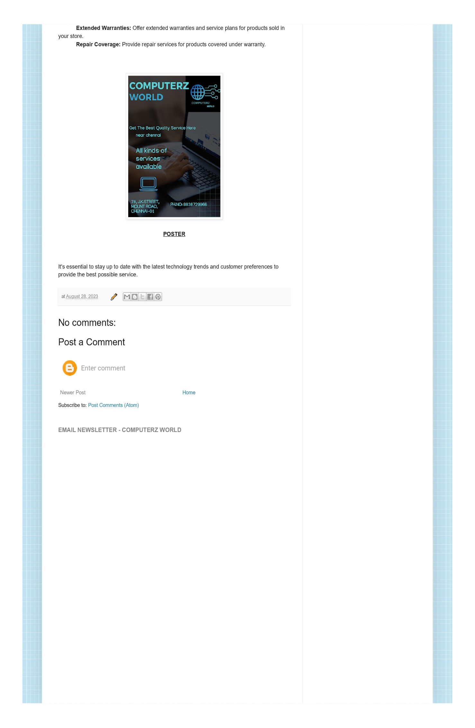

1. Create a New Facebook Business Page and post one social media poster for your brand.

Link: <https://www.facebook.com/computerzworlds>

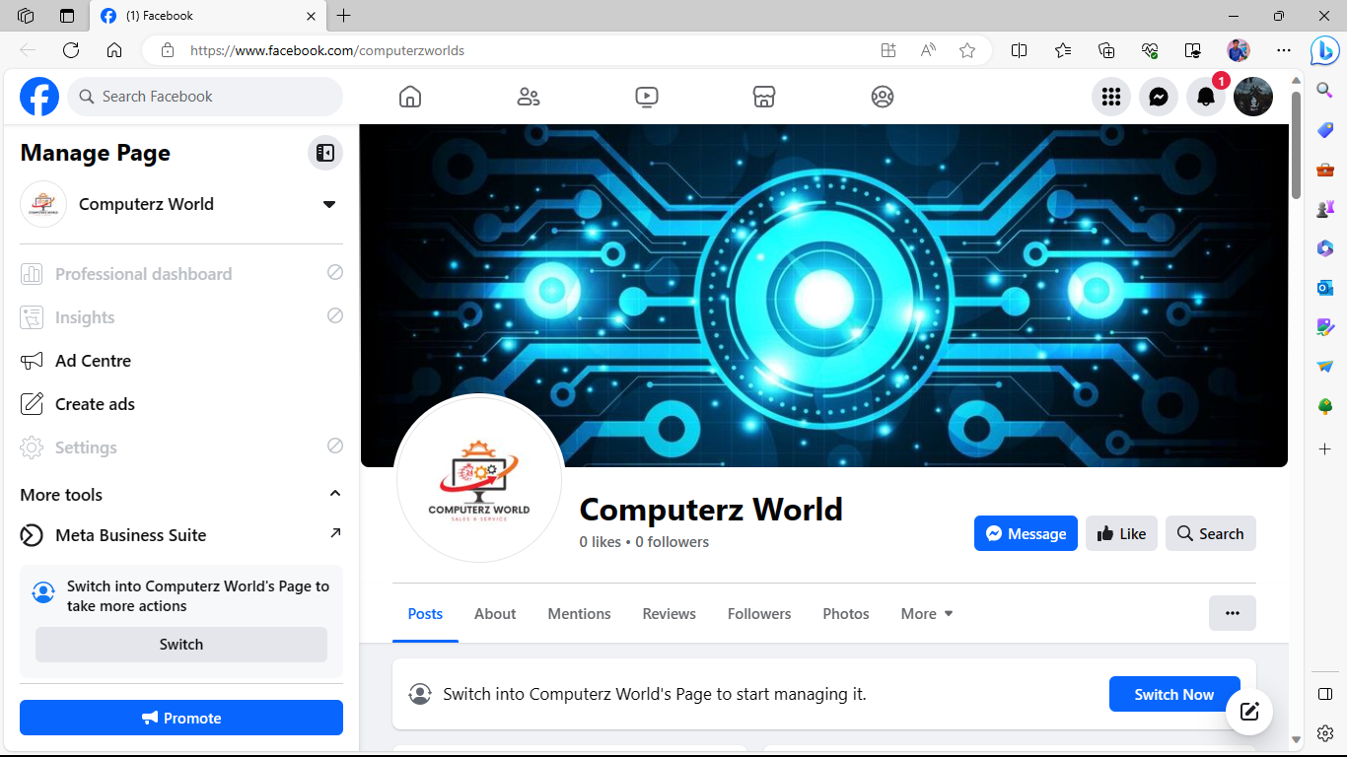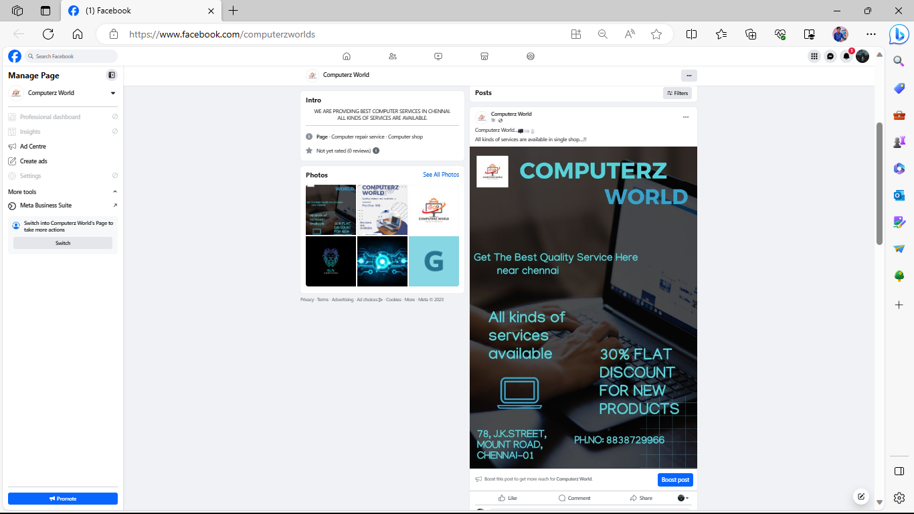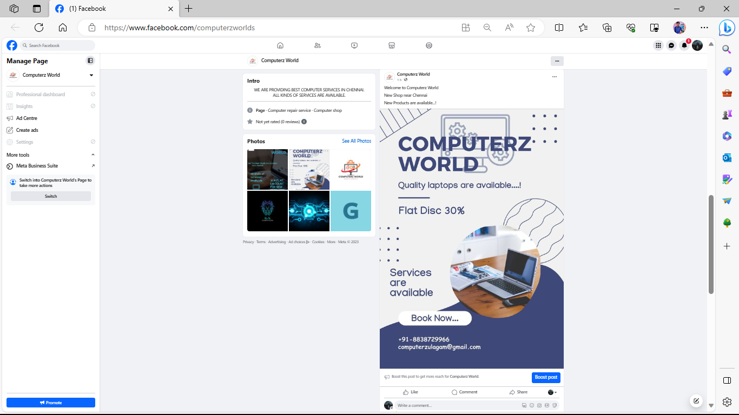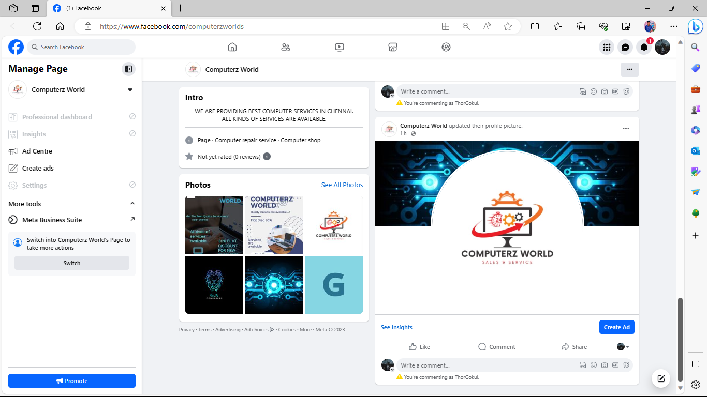

1. 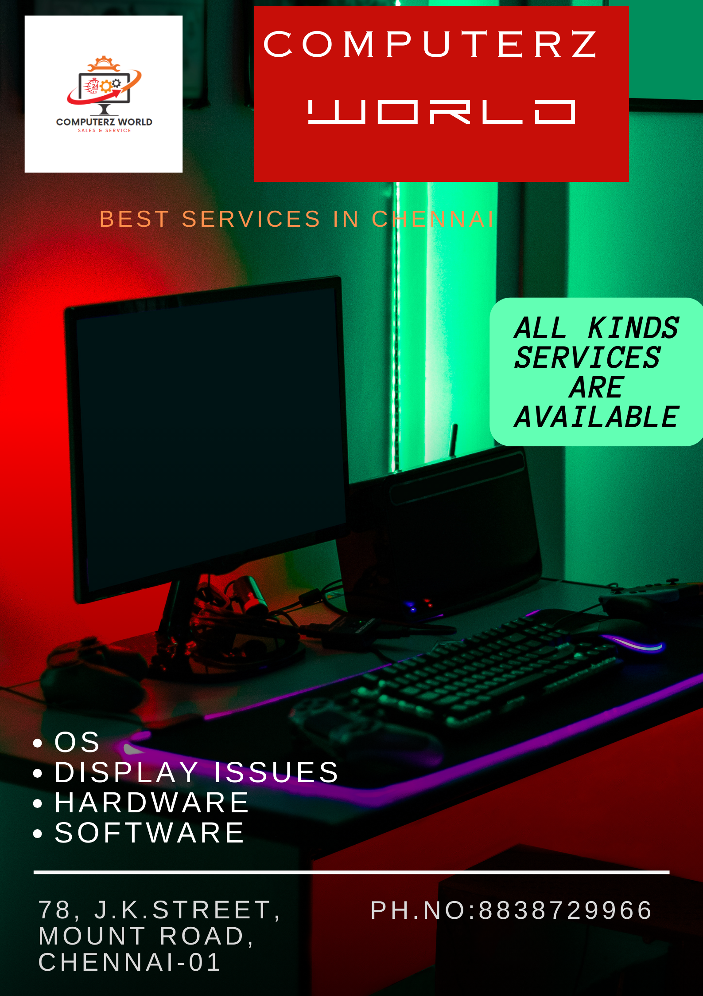Create and design a social media advertisement poster using canva.



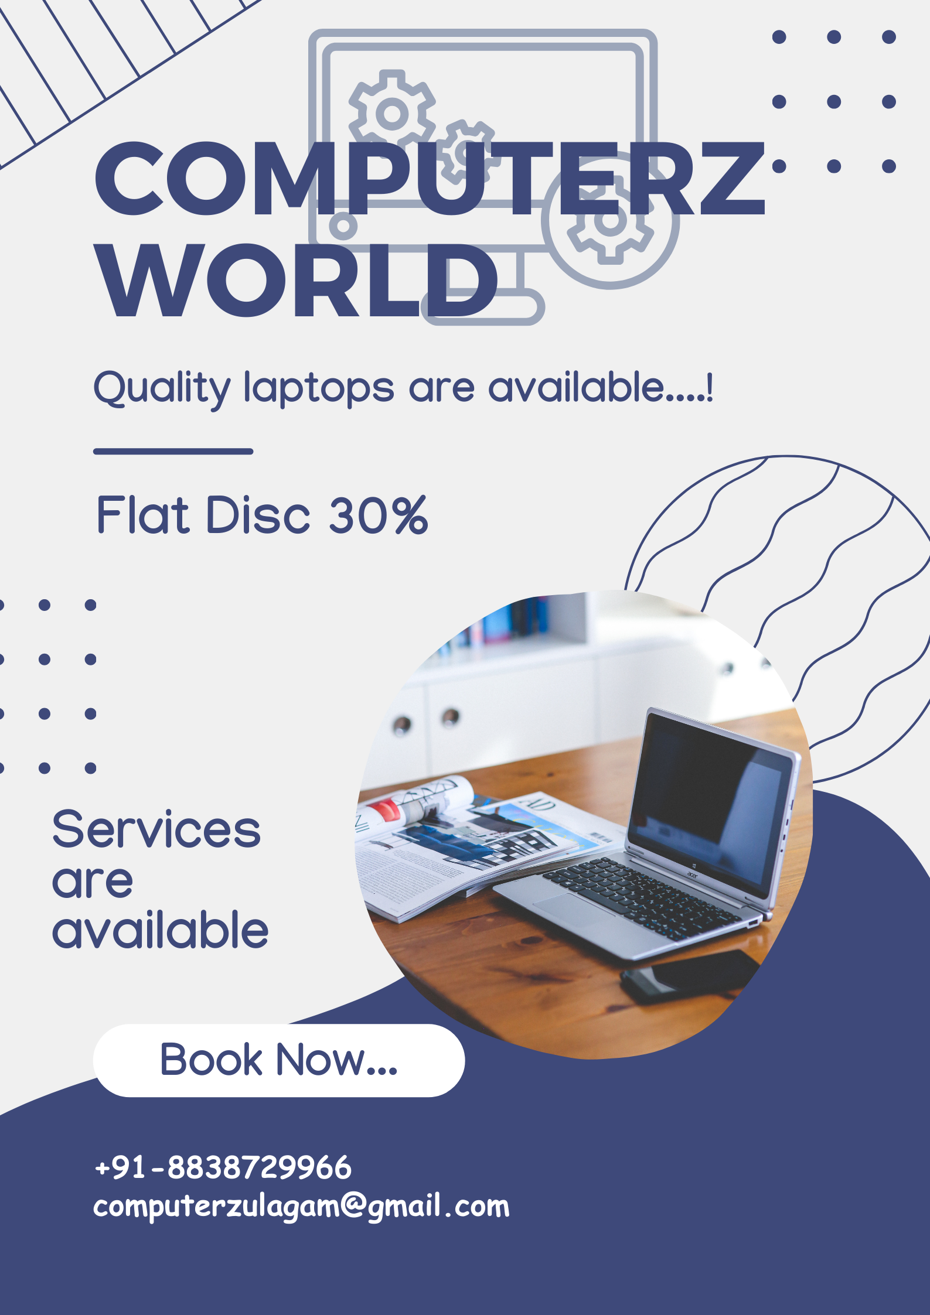

1. Create email newsletter design using MailChimp or canva tool.

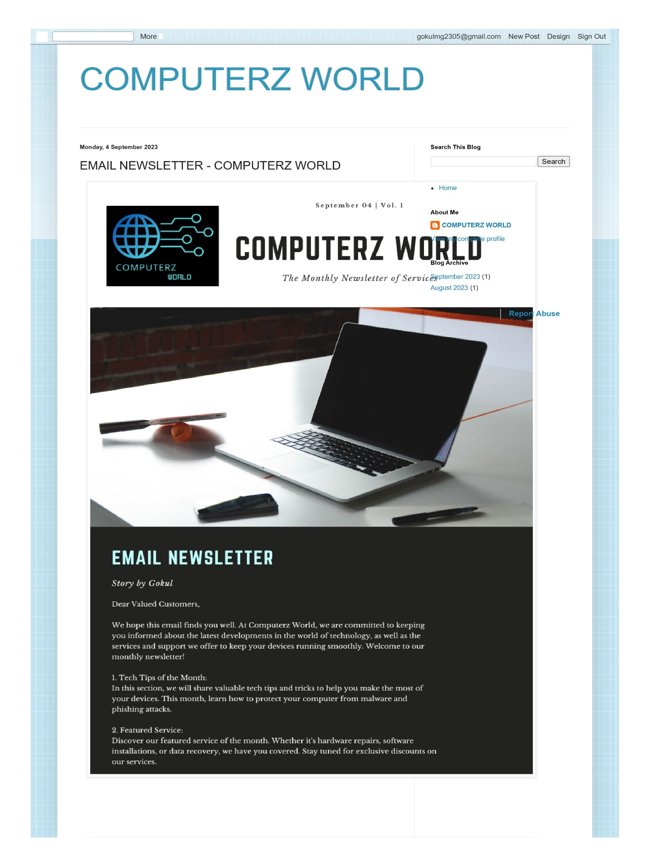Link: <https://computerzzzworld.blogspot.com/2023/09/email-newsletter-computerz-world.html>

